Figs
JBone
2025-02-03

Introduction
Influenza A viruses frequently cross host-species boundaries and in doing so, exemplify zoonotic spillover risks. The potential for IAV cross-species emergence is one of the most keenly felt infectious disease threats in the world. The proclivity of these viruses to circulate in multiple vertebrate species, including many of the species reared agriculturally, emphasises the importance of understanding how and when host-jumps may occur. In addition, huge amounts of resources are spent annually to try and predict whether IAV will jump between species, and which species and strains may be involved in (re-)emergence. To predict these cross-species transmission events, many different aspects of influenza virus biology are routinely surveyed: evolutionary history, ecological contact networks and structural modelling of host-pathogen protein interactions, to name but a few. However, exploring these features independently can obfuscate patterns and/or lead to repetition of often labour-intensive and costly analyses. The main aim of this study is to interrogate two methods of observing host-adaptation in influenza A viruses that have previously jumped from one species into another. We focus on detecting signal(s) of adaptation to the original host that linger in the virus that circulates in the secondary host species. Specifically, phylogenetic trait-based analyses are compared against molecular and structural characteristics of viral proteins in order to determine putative benefits of a multi-faceted approach in understanding (and therefore hopefully, eventually predicting) host jumps; in other words, is the relationship between protein structures already accounted for by viral phylogenetic histories?
Our cross-specialisation approach first uses protein compositional features to train machine learning models to classify the original host each virus was obtained from. Viral proteins have long been examined in order to understand and mitigate the infection process: proteins that mediate viral entry into host cells, those that usurp cellular machinery or antagonise cellular defences, and proteins that interact directly with adaptive immune molecules of the colonised host.
Finally, we compared the results of both modelling and phylogenetic approaches to detect any overlap or, more interestingly, any inferences that were exclusive to only one method. In examining two ways to detect signal of adaptation to an original host, we explore where methods agree, where they disagree and which is the “best” moving forward.

Methods

Sequences

Sequence Collection
Sequences were collected from NCBI Virus Database. This dataset was filtered to only include samples with: a) complete nucleotide sequences, missing no more than 10% of the average length for that segment; b) metadata containing the virus subtype and original host, at least up to the Class level (Aves or Mammalia) through preferably detailing all the way down to the Family or Species. Nucleotide sequences were then assigned a random identifier (between AAA-000-AAA and ZZZ-999-ZZZ) to associate with metadata throughout analyses. 14,682 avian and 21,737 mammalian sequences were collated at this stage.
Samples from mammalian hosts were then retained only if the original host was within the Canidae, Suidae, Equidae, Hominidae or Phyllostomidae (New World bats) families, as viruses within these hosts were expected to display clear examples of host-adaptation as well as having a history of cross-species transmission. Viral sequences of mammalian-origin were then reduced further by excluding samples where the subtype does not circulate naturally within closed systems of that host (i.e. removing spillovers or stuttering chains of transmission, neither of which represent the kind of host adaptation we sought to detect). Included subtypes for each family were: canine (H3N2, H3N8), equine (H7N7, H3N8) and human (H1N1, H1N2, H2N2 and H3N2). Whole-genome sequences from bats were so sparse that all examples were retained and the breadth of diversity found in swine-origin viruses meant that all subtypes were included from this family.
Corresponding protein sequences were then obtained for each sample, most of which were available from the NCBI Virus Database. The few genomic sequences without matching proteins were translated locally using the ‘ape’ package in R Paradis and Schliep (2019).

Clustering
Proteins were then aligned using MAFFT Rozewicki et al. (2019) into 20 resulting protein fasta files (two for each of the 10 major IAV proteins, one containing mammalian-origin viruses and the other avian-origin). These were then clustered using the linear algorithm easy-linclust within the tool MMSeq2 Steinegger and Söding (2018). Three variables of the clustering algorithm were experimented with in optimising data retention: the percentage identity threshold required to delineate sequences from one another (–min-seq-id 0.75, 0.85, 0.9, 0.95, 0.99), coverage of the sequences within each cluster (-c 0.5, 0.7, 0.8) and the way in which the coverage is calculated (–cov-mode 0, 1). Each possible combination was tested for avian and mammalian viruses [Supp Table 1].
Options were set to --min-seq-id 0.95, -c 0.8 and --cov-mode 1 in order to grant a representative number of samples without introducing redundancy. Ultimately, 6,697 proteins were retained by clustering leading to sequences from 4568 individual viruses.
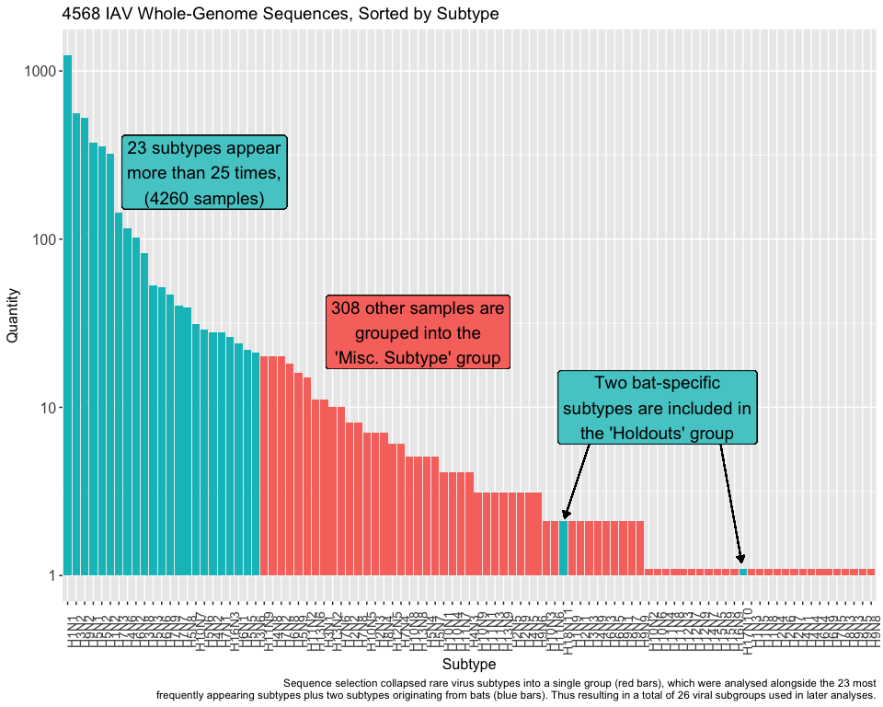

Model Creation

Protein Features
Proteins from avian-origin and mammalian-origin viruses retained by the clustering algorithm within MMSeq2 were then aligned into a single fasta file for each protein. Accessory proteins (PB1-F2 and PA-X) were then removed from the analyses as both lie within the coding regions of their respective genomic segments and thus the calculation of any features from sequence data would already include these regions. Similarly, those spliced from alternate reading frames (M2 and NEP) were excluded from any further analyses as they were too short and/or conserved to show patterns of adaptation.
OmegaFeaturesCLI Chen et al. (2022) extracted matrices of protein compositional and physio-chemical properties from alignments with the ‘get_descriptor’ command. Features, and the associated command, are as follows: 2mers (‘DPC type 1’), Chou’s pseudo-amino acid composition (‘PseAAC’), conjoined triad (‘CTriad’), and finally Composition (‘CTDc’), Transition (‘CTDt’) & Distribution (‘CTDd’) values.
Six datasets of protein features were derived from the iFeatureOmega processing: amino acid two-mers (DPC, 400 features), (CTDc, CTDd and CTDt, 39, 195 and 39 features respectively), paac (23 features) and triad (343 features). These were then annotated with the subtype of the origin virus and labelled with the original host.

Machine Learning Models
Matrices of protein features were then used to create Random Forest classification models, to distinguish between the host from which viruses were sampled.
In order to create test data, subtypes that appeared most frequently (>20 times) were iteratively held out of model construction. In addition to these 23 subtypes, both bat-exclusive subtypes (H17N10 and H18N11) were held as test data. The remaining 70 subtypes comprised $\frac{308}{4551}$ (~7%) sequences. Six Random Forest models were created from each of the feature datasets, for each holdout. These models were then stacked with the use of the ‘caretEnsemble’ package (Deane-Mayer 2024). Models were weighted in order to accommodate for disproportionate sizes of host groups by using the inverse of that group’s proportion.
These datasets were then used to train Random Forest models, leading to 2400 models in total: 8 proteins, 6 chemical and compositional features, 25 subtype holdouts and either two-class or multi-class models. Each models’ training statistics were extracted for preliminary validation. Models for each protein and subtype were then compiled with the stacking algorithm by caret.

Pipeline of machine learning model construction. One model was created for each combination of variants, which were then collated into stacked models to inform and train across broader sample sizes.

Model Performance
Models were assessed with common ML model comparison metrics: accuracy, precision, sensitivity & specificity and balanced accuracy (BA). All performance metrics were carried out courtesy of the MLmetrics package Yan (2025).
This measure of performance ($BA=\frac{TPR+TNR}{2}$) so the closer TPR+TNR is to 1, the worse the model. This is because the model is overestimating positive hits and is unable to distinguish reals from fakes – i.e. which is equivalent to the expected value of a random guess in a balanced data set.

Predictive Measures

Phylogenetics
Using sequence data from each of the 8 proteins studied phylogenetic trees were estimated. Initial model parameters such as evolutionary and codon-partitioning models were estimated by ModelFinder within IQTree2 Minh et al. (2020), and temporality was confirmed with TempEst (Rambaut et al. 2016).
Protein
Model
PB2
FLU+R4
PB1
FLU+R4
PA
FLU+R5
HA
FLU+R8
NP
Q.mammal+R4
NA
FLU+R5
M1
Q.mammal+R3
NS1
HIVw+R6
Maximum Likelihood trees were estimated in IQTree2 with the substitution models suggested by ModelFinder (Table 1) and bootstrapped 1000 times for validation.
Phylogenetic models were first trialled on Maximum Likelihood trees with the use of BayesTraits v3.0 (Meade and Pagel 2022); in the R wrapper “btw” (Griffin 2018). First, a discrete-trait analysis estimated the origin host of viruses, protein features were then modelled as continuous traits. Trait analyses were first modelled the features of tips and then ancestral trait reconstruction upon internal nodes, both using multi-state reverse-jump MCMC procedures. Transition rates between discrete states (i.e. Host) were examined across each protein tree before the states of ancestral nodes were estimated.

Ancestral Trait Reconstruction
Specific nodes were selected for ancestral trait reconstruction due to known historical host-switching events. Recognised host switch events include: human viruses that originated from avian and swine reassortments in 1918 (H1N1), 1957 (H2N2) and 1968 (H3N2); emergence of swine viruses into human pandemic strains (H1N1_{pdm09}); avian IAV into horses (H7N7 and H3N8) and the jump of equine H3N8 viruses into canine populations.
####### HA Node 1 #######
nexTree <- read.nexus("HA.nexus")
tree_scaled <- scaleTree(nexTree)
feature_meta <- read.table(paste0("IAV/varimp_HA_values.txt"))
ace_cmd <- c("1","2","RevJump exp 10","AddTag TRecNode ASB30836_BHI882BVL_Canidae_2011 AEX30515_NPS021OCG_Equidae_2010.311111 ACH95671_ZVA445GAI_Suidae_2005.955556 AEM60113_KOI765MSE_Equidae_1979 AEM60147_ATB639FJH_Equidae_1971","AddNode RecNode TRecNode")
features_ACE <- bayestraits(feature_meta, tree_scaled, ace_cmd, silent = FALSE)
features_ACE$Log$results %>% select(-c("No.Off.Parmeters","No.Off.Zero","Model.string",starts_with("Root"))) %>% write.csv(paste0("IAV/HA Node 1 Feature Reconstruction.csv"))

Results

Dataset Curation
In total 36,419 sequences were found eligible for study (14,682 avian and 21,737 mammalian).
Protein
Avian
Mammalian
PB2
338
561
PB1
303
255
PA
282
415
HA
1406
919
NP
215
244
NA
185
207
M1
73
149
NS1
539
606
The clustering resulting from removing sequences with a 95% sequence identity left us with 6,697 protein sequences overall. To assist with building the model architecture, any virus genome that had at least one representative protein was analysed fully - hence 4,551 viruses were analysed, despite the high sequence homology between many of the proteins except for the selected representative protein. The number of representative proteins called by the clustering algorithm is shown in Table 2 and full lists of the associated accession codes are available in Supplementary 1.

Protein Models
Confusion matrices were made on the known origin host and the host predicted by the machine learning models. Matrices were used to assess model predictive strength. Incorrectly labelled viruses were indicative of signal of possible adaptation to the host from which a virus originated.
Protein
F1.micro
F1.macro
AUC
PB2
0.843
0.518
57.00%
PB1
0.807
0.384
52.70%
PA
0.875
0.575
57.50%
HA
0.770
0.295
55.80%
NP
0.884
0.496
55.60%
NA
0.735
0.332
52.70%
M1
0.863
0.517
55.90%
NS1
0.910
0.519
56.50%
Counter-intuitively, a lower model accuracy implied greater evidence of adaptation to the host species; the mislabelling of proteins is indicative of host-specific adaptations to non-native hosts. For example, should a human-origin virus be incorrectly labelled as swine-origin by the model, this supports the hypothesis that the protein retains some signal of adaptation to the original swine hosts. Overall, confusion matrices were evaluated based on accuracy and F1 statistics (shown in Table 3).
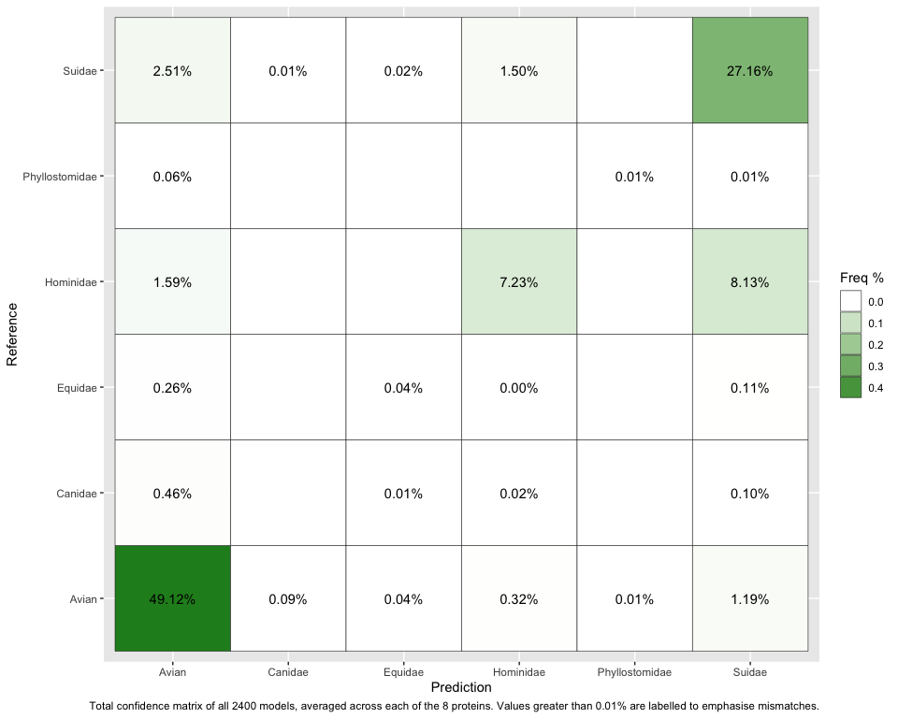 Main outliers (>1%) are pig-human-avian though maybe just caused by the relative proportion of these. The RF models do show good estimation of true-positives, especially for the most frequently appearing samples. Interestingly though, the biggest mistake that the model made was of misclassifying human-origin sequences as pig-origin. In fact, more of the human sequences were incorrectly classified as swine (8.13%) than correctly identified (7.23%).
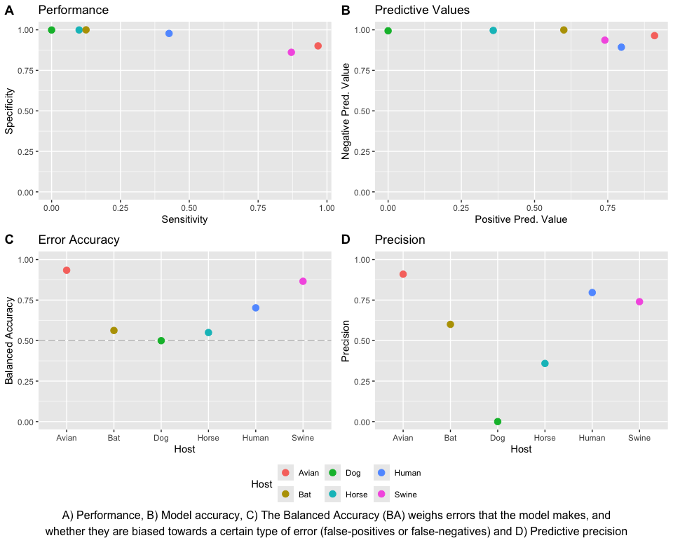
Analysing the results of random forest classification models based on the protein characteristics alone, predicted host class varied heavily depending on the host. First, all models have high (>75%) specificity but sensitivity varies wildly. This isn’t helped by the sparsity of canine, equine and bat samples in the dataset.
Again, high negative predictive and varying positive predictive values are likely influenced by the relatively small number of sequences from viruses originating from bat, dog and horse hosts. Weirdly, proteins from bat viruses seem to perform better than those from canine and equine hosts; maybe the sparsity of proteins from dog and horse viruses throw things off more than the bats which are highly divergent to other IAV. However, both of these first two measures imply that host signal is evident in the protein chemical features but extrapolating this to actual cross-species jumps is less reliable.
In model performance, dog-origin viruses are the only time that the models are basically guessing randomly, reflected in the Balanced Accuracy.
Overall though, the models perform pretty well given how complex this is and the fact that it is just based on 1039 protein features alone

Protein Features
By running ML models and iteratively removing each protein feature, the model performance statistics can be used to infer which features cause performance to drop the greatest. Hence, taking out the features and re-running the model allows us assess the impact that that feature had on model performance. The drop in AUC is used to assess the importance of each feature within each ML model.

Mismatches
Matched
Mismatched
Protein
raw
%
raw
%
01PB2
404
74%
145
26%
02PB1
375
68%
179
32%
03PA
573
83%
118
17%
04HA
1760
88%
240
12%
05NP
219
56%
173
44%
06NA
316
81%
76
19%
07M1
145
66%
76
34%
08NS1
1008
92%
90
8%
When did the model predict things incorrectly? Was there any pattern to the mistakes? Not really…

Protein Features
This is the variable importance stuff, explain better how it was done and what the AUC loss means
By running ML models and iteratively removing each protein feature, the model performance statistics can be used to infer which features cause performance to drop the greatest. Hence, taking out the features and re-running the model allows us assess the impact that feature had on model performance.
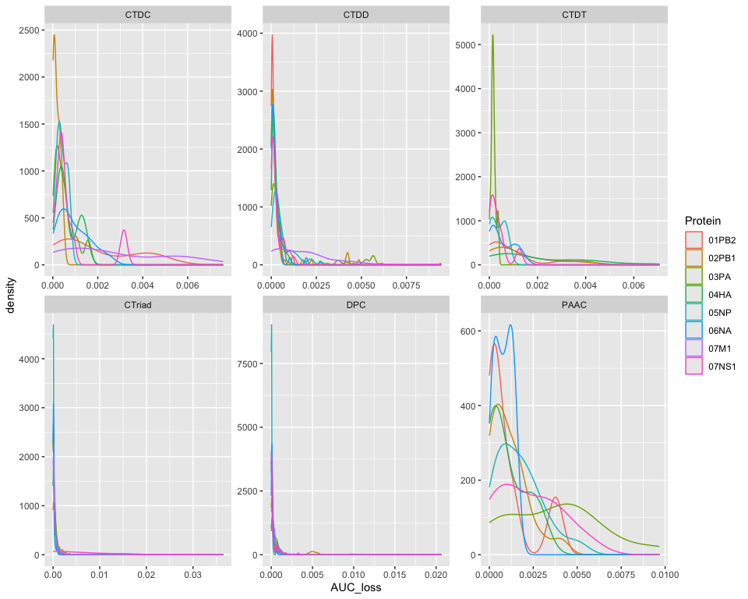

Phylogenetics
Alignments of each of the eight proteins were used to estimate trees using IQTree2.
Could also stick some quick diversity measures in for each alignment, to show what we’re working with?
How correlated are protein features, length and diversity?

Protein Trees
Is it worth adding bootstrap values? Or describing the tree (num of tips/nodes) just to clarify that some sequences were excluded from tree estimation?
Trees with Protein Features
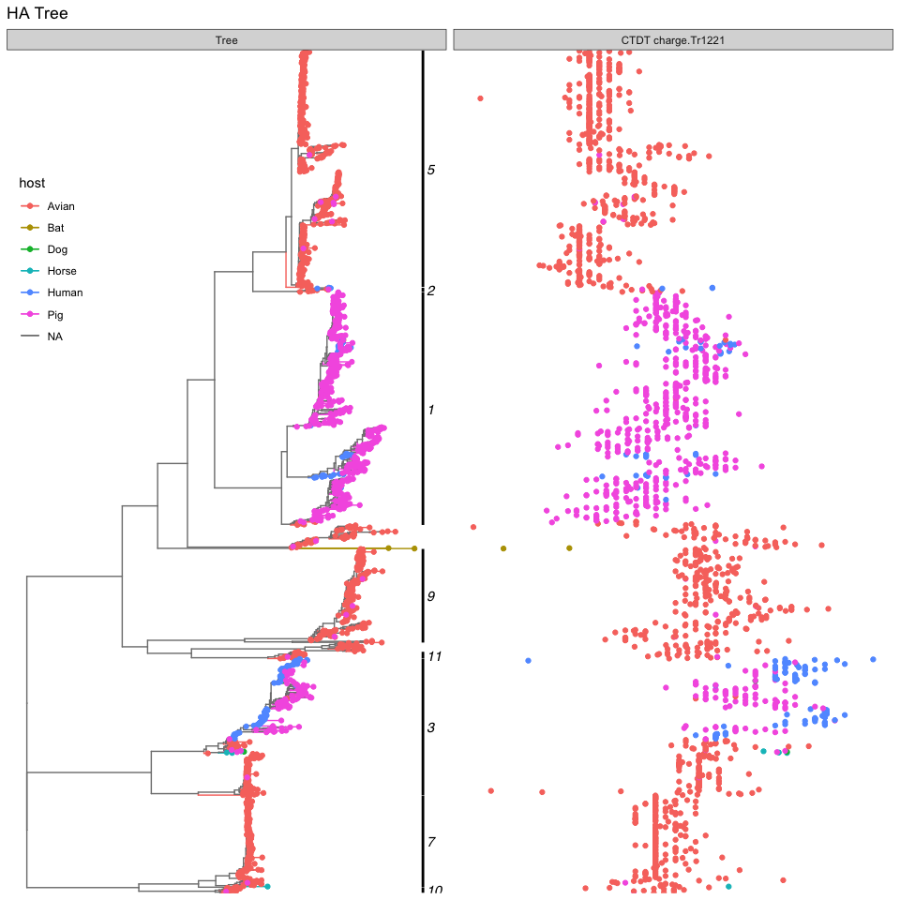
Is there correlation between charge and branch length/placement? Would need a nice branch-branch measurement like Faith’s PD

Trait Analyses
Transition rates between hosts, based on entire trees when the ONLY feature input to the phylogenetic model is host. i.e. given the distribution of hosts throughout the tree, what is the likelihood that any given branch will transition from host₁ to host₂?
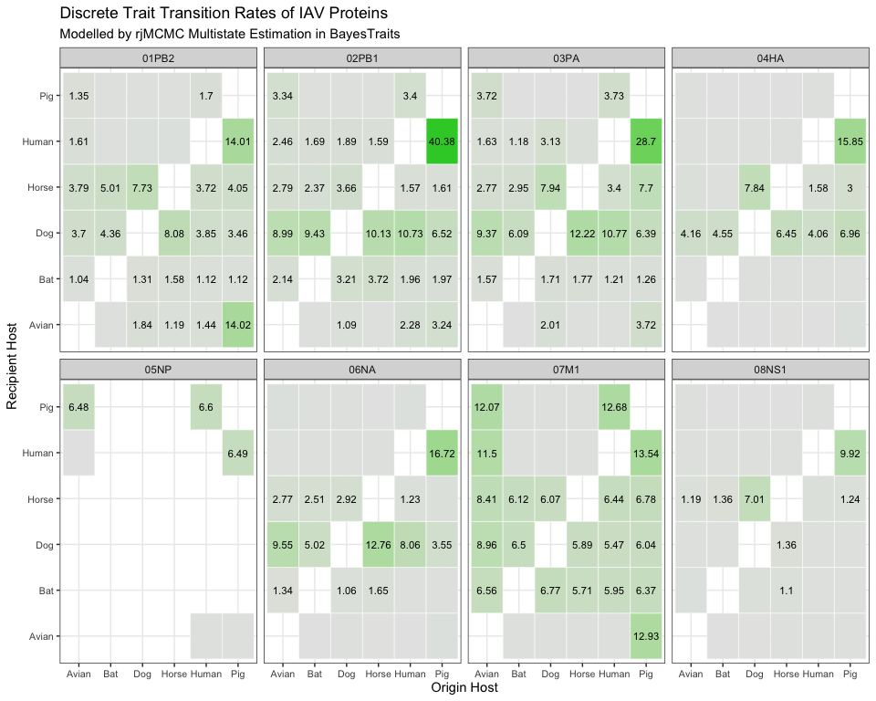
Interesting how rarely avian is estimated as the donor, considering reality
Wonder if the pig -> human values would drop if pdm_2009 were held as a separate group of sequences
Nice horse-dog rates given how closely related they are
Also interesting when matrices are asymmetrical, indicates a direction of transfer from the phylogenetic signal

Ancestral Reconstruction
Describe subtree selection:
- node number
- number of tips
- why were these subtrees selected
Bayestraits ACE output gives the model iteration, the current likelihood of the chain, tree number, the features used in model training (10 protein features, 0 - 9), the labelled traits (six host types, A, B, D, E, H, P), actual transition rates (q_{0,A} - q_{9,P}) and finally the traits estimated from the preceding values.
## X Iteration Lh Tree.No q.0 q.1 q.2 q.3
## 1 1 11000 -478.5072 1 0.001333 0.123110 0.001333 0.000000
## 2 2 13000 -410.8597 1 0.003522 0.003522 0.003522 0.003522
## 3 3 15000 -408.1938 1 0.004710 0.004710 0.004710 0.004710
## 4 4 17000 -395.8061 1 0.003237 0.003237 0.003237 0.003237
## 5 5 19000 -393.2918 1 0.000000 0.003180 0.003180 0.003180
## 6 6 21000 -395.7123 1 0.002598 0.002598 0.002598 0.002598
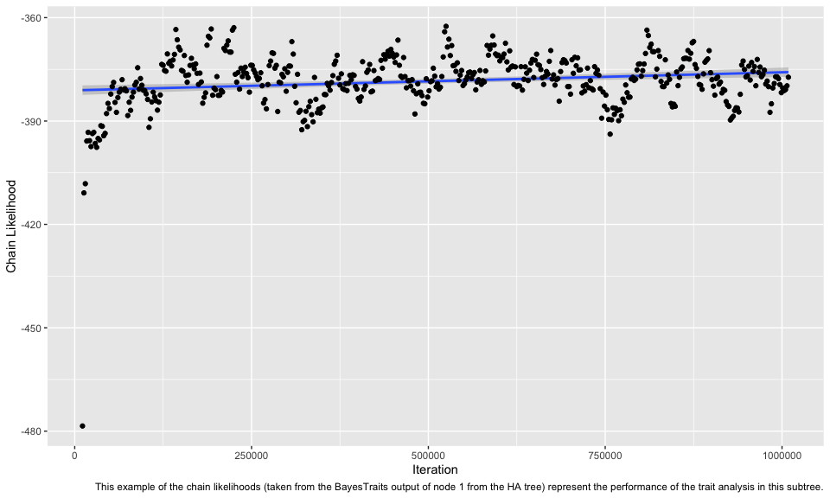
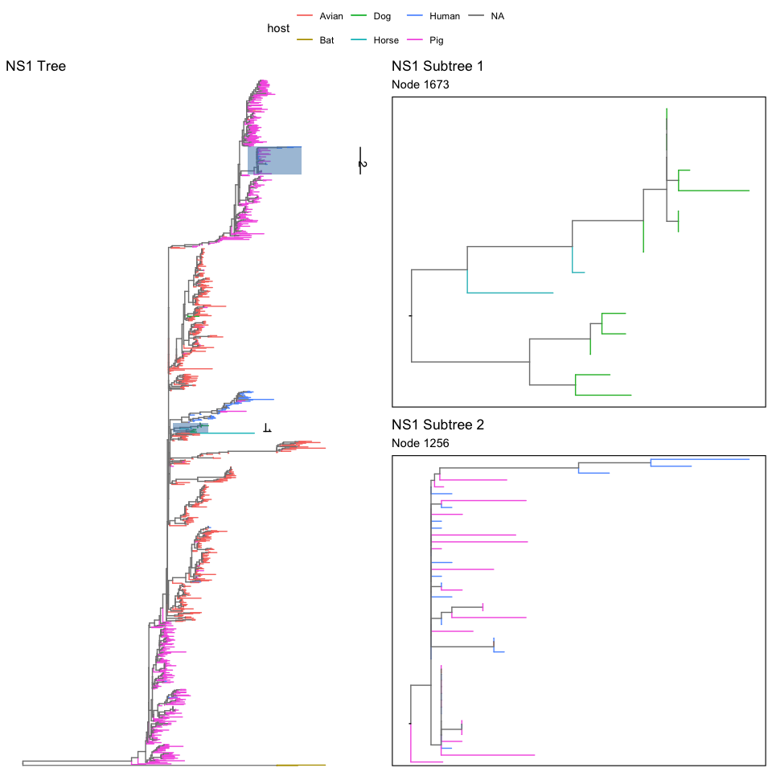
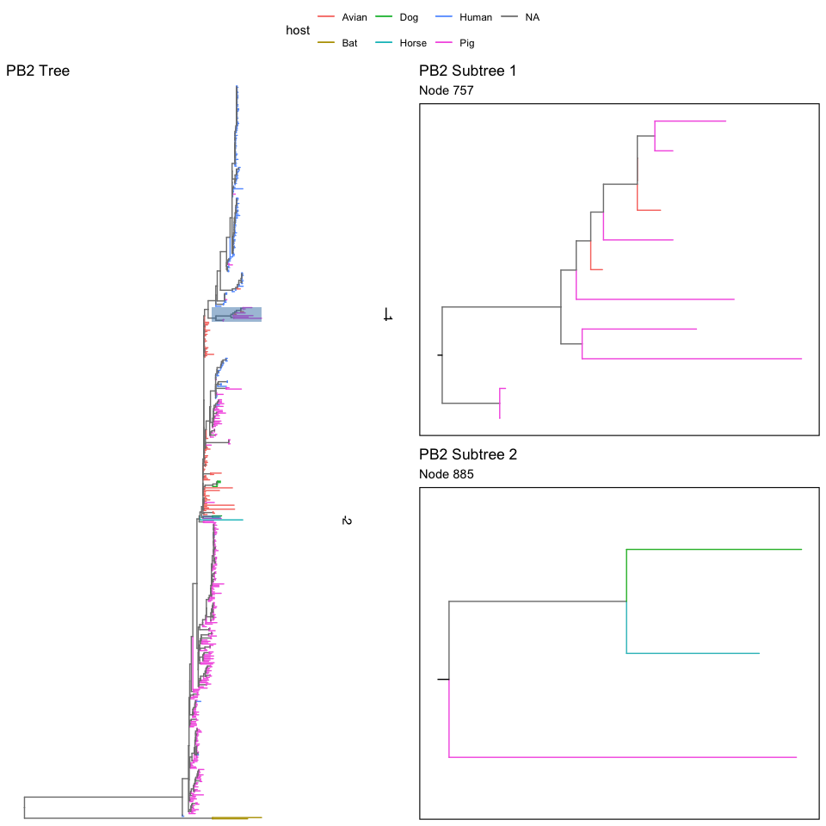
## [1] 3493 1503
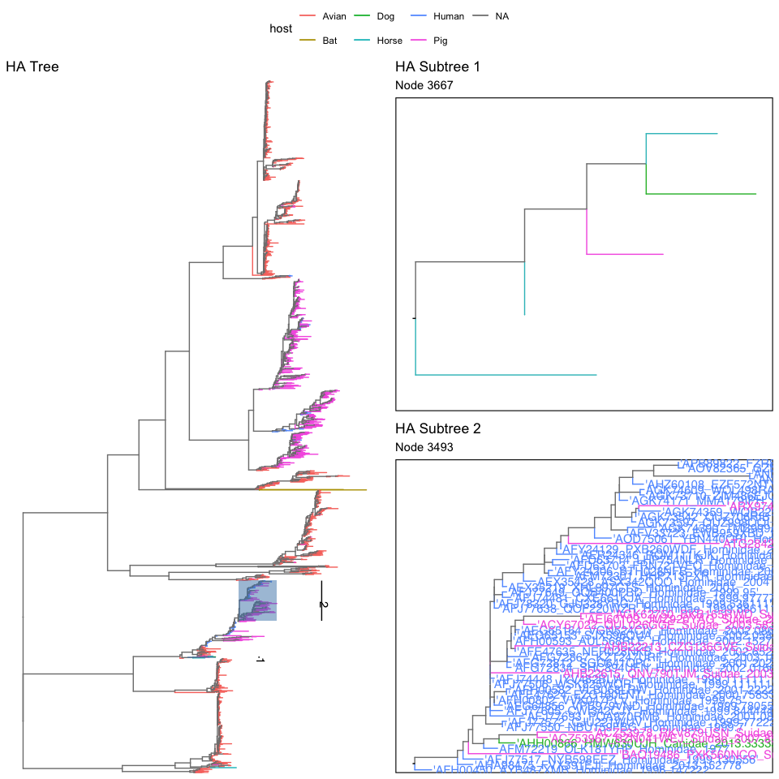
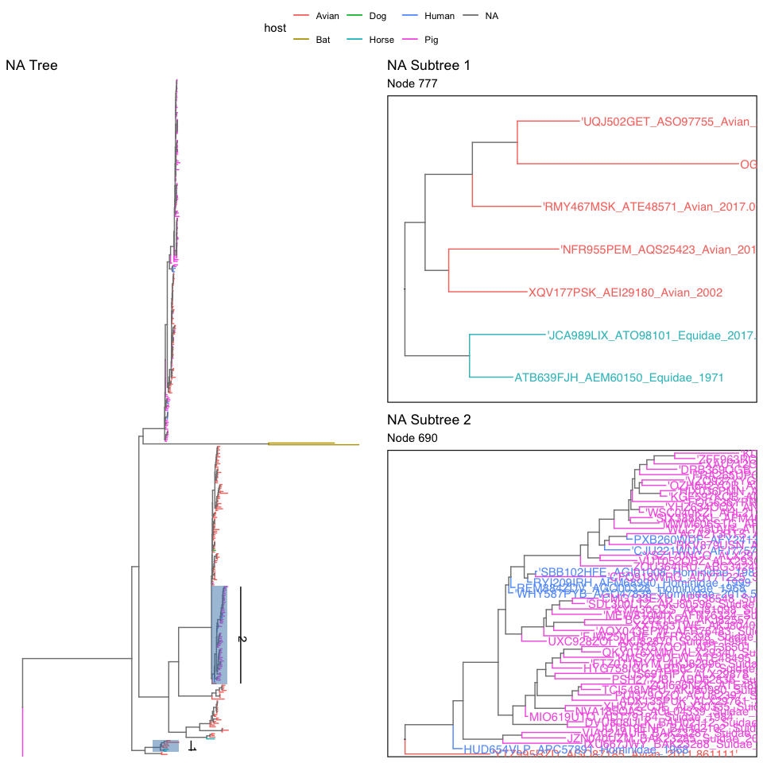

Discussion
All protein sequences in the dataset were classified into one of six hosts by the array of machine learning models. These classifications, modelled exclusively from protein physio-chemical properties, were then compared with the known host from which the virus was isolated. Each value is the proportion of whole-virus sequences across the entire dataset, only groups with more than 0.01% of sequences are labelled in the heatmap. While the majority of sequences were predicted to come from the correct host (83.57% in total), the focus of this study is rather on the misclassifications; potentially indicative of signal representing species-specific adaptation, and thus taken here as a proxy for successful cross-species emergence. Hence, correct predictions are removed from the heatmap for emphasis. As an example, 2.51% of sequences ($\frac{843}{33,647}$) were predicted by the machine learning models to be swine IAV when they were in fact sampled from avian hosts. Similarly, 8.31% ($\frac{2737}{33,647}$) of sequences were mislabelled as human-origin viruses despite originating from swine.
The phylogenetic modelling rather calculates the transition rate of sequences between labelled metadata groups (i.e. host). Given the phylogenetic structure of the samples, and the labels assigned to each tip (the origin host), the likelihood of sequences moving between classes (i.e. sustained cross-species emergence and adaptation) is given as an expected transition rate. For example, the rate of bat virus emergence in avian populations is modelled as very unlikely (0.19), whereas viruses from pigs appear highly liable to spillover and then adapt into human hosts (18.2). Both of these predictions align with the observed ecology of IAV over the past century and a half; swine viruses have repeatedly crossed into human populations. To note, these transition rates are not estimated to be symmetrical – the flow of IAV between humans and swine is heavily unidirectional, with a rate of 3.76 in human → swine emergence compared to the above example (18.2 in swine → human cross-species transmission).
In the future, we would’ve clustered per host and also possibly split the birds up more into ‘waterfowl vs others’ instead of assuming that all birds are always the source of infection. Other potential subdivisions include the splitting of human H1N1 viruses into two distinct classes of pre- and post-2009 samples in order to distinguish already circulating viruses from those that emerged during the 2009 swine flu pandemic.

Sequence Reconstruction
In order to test the models further, protein features of the internal nodes could be calculated. Of course, the majority of these internal nodes do not have sequences collected. To circumvent this, a further step of our analyses could be to reconstruct ancestral sequences. By estimating the sequence of an internal node, it can then be re-input into iFeaturesOmega. Then, if our hypothesis stands, the features of these inferred proteins ought to be an average of the two descendants. CodeML is suggested as a tool for reconstructing ancestral protein sequences.

References
Chen, Zhen, Xuhan Liu, Pei Zhao, et al. 2022. “iFeatureOmega: An Integrative Platform for Engineering, Visualization and Analysis of Features from Molecular Sequences, Structural and Ligand Data Sets.” Nucleic Acids Res 50 (W1): W434–47. https://doi.org/10.1093/nar/gkac351.
Deane-Mayer, Zachary A. 2024. caretEnsemble: Ensembles of Caret Models. https://CRAN.R-project.org/package=caretEnsemble.
Griffin, Randi H. 2018. Btw: Run BayesTraitsV3 from r. https://github.com/rgriff23/btw.
Kalyaanamoorthy, Subha, Bui Quang Minh, Thomas K F Wong, Arndt von Haeseler, and Lars S Jermiin. 2017. “ModelFinder: Fast Model Selection for Accurate Phylogenetic Estimates.” Nature Methods 14 (6): 587–89. https://doi.org/10.1038/nmeth.4285.
Meade, Andrew, and Mark Pagel. 2022. “Ancestral State Reconstruction Using BayesTraits.” In Environmental Microbial Evolution: Methods and Protocols, edited by Haiwei Luo. Springer US. https://doi.org/10.1007/978-1-0716-2691-7_12.
Minh, Bui Quang, Heiko A Schmidt, Olga Chernomor, et al. 2020. “IQ-TREE 2: New Models and Efficient Methods for Phylogenetic Inference in the Genomic Era.” Molecular Biology and Evolution 37 (5): 1530–34. https://doi.org/10.1093/molbev/msaa015.
Paradis, Emmanuel, and Klaus Schliep. 2019. “Ape 5.0: An Environment for Modern Phylogenetics and Evolutionary Analyses in R.” Bioinformatics 35: 526–28. https://doi.org/10.1093/bioinformatics/bty633.
Rambaut, Andrew, Tommy T. Lam, Luiz Max Carvalho, and Oliver G. Pybus. 2016. “Exploring the Temporal Structure of Heterochronous Sequences Using TempEst (Formerly Path-o-Gen).” Virus Evolution 2 (1): vew007. https://doi.org/10.1093/ve/vew007.
Rozewicki, John, Songling Li, Karlou Mar Amada, Daron M Standley, and Kazutaka Katoh. 2019. “MAFFT-DASH: Integrated Protein Sequence and Structural Alignment.” Nucleic Acids Research 47 (W1): W5–10. https://doi.org/10.1093/nar/gkz342.
Steinegger, Martin, and Johannes Söding. 2018. “Clustering Huge Protein Sequence Sets in Linear Time.” Nature Communications 9 (1): 2542. https://doi.org/10.1038/s41467-018-04964-5.
Yan, Yachen. 2025. MLmetrics: Machine Learning Evaluation Metrics. https://github.com/LqNoob/Machine-Learning-Evaluation-Metrics.

